Weekly Prayer List
Sunday, November 6
8:30am – Choir Rehearsal
10:00am – Worship & Children’s Sunday School
6:00pm – Boy Scouts/Cub Scouts

Monday, November 7
7:30am – Men’s Breakfast (Luna’s)
8:15am – Bootcamp Exercise Group
10:30am – Women’s Bible Study
6:00pm – Jazzercise

Tuesday, November 8
6:00pm – Jazzercise
11:45am – Men’s Lunch (Bob Evans, Macedonia, Oh)
6:30pm – Women’s Bible Study
7:30pm – Serenity Group

Wednesday, November 9
8:15am – Bootcamp Exercise Group
11:30am – Faithful Friends
6:00pm – Jazzercise
8:00pm – Open Arms Support Group

Thursday, November 10
9:30am – Nordonia Hills Community Connection
6:30pm – Kitchen Talk Support Group

Friday, November 11
8:15am – Bootcamp Exercise Group
7:00pm – Come and Get it Support Group

Saturday, November 12
8:30am – Jazzercise
12:00pm – Elexis Maynard – 1st Birthday Party

Sunday, November 13
8:30am – Choir Rehearsal
10:00am – Worship & Children’s Sunday School
6:00pm – Boy Scouts/Cub Scouts

This Week at UMCM

In Our Prayers:
- Bob Hohs, who will be having outpatient hernia surgery on Thursday, November 10th at Hillcrest Hospital
- Rose Bowman, who is recovering from foot surgery on Tuesday, November 1st.
- Taylor Edgell, who is recovering from an accident and is in a hospital in Columbus, Ohio.
- Morris and Monnie Nordland (brother and sister-in-law of Carolyn Schneider), are both at home recovering.
- Cheryl Taylor, prayers for healing in her right knee.
- Judy Haddix, for continued recovery from gallbladder surgery.
- Russell Wolfe, who is at home under hospice care.
- Ron Setar, who is at Akron General Hospital having surgery on Thursday, November 3rd to remove a kidney stone.
- Caroline Pickering, who is now at home recovering.

Giving Thanks to God:
- Praise God for the UMCM Tech Team and all their hard work!
Altar Flowers:
- In Memory of All Saints
- Veterans Day

____________________________________________________
____________________________________________________
____________________________________________________
____________________________________________________

Announcements:
- Check the website and your weekly updates email for other important announcements!
- Last week’s offering was: $5,472.27
- Last week’s attendance was: _86_ In Person, _16_ Online, & Views

The United Methodist
Church of Macedonia

November 6, 2022
All Saints
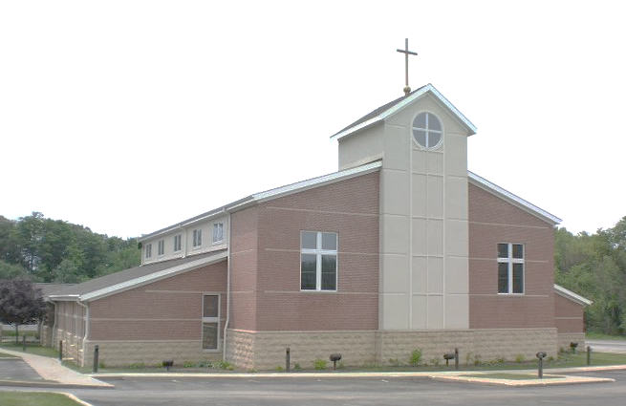

1280 E. Aurora Rd. Macedonia, Ohio 44056
(330) 467-3169
www.umcofmacedonia.org

Senior Pastor: Rev. Lorrin Radzik
Minister of Congregational Care: Rev. Charles Tobias
Administrative Assistant: Denise Pince
Director of Christian Education: Cathy Miller
Choir & Music Director: Emilio Jarufe
Organist: Amy Sauriol
Treasurer & Media Specialist: Jill Marlow
Thank you for joining us today! To assist you during worship this morning, we offer wireless listening devices, as well as large print bibles and hymnals. Please know that we always love to have the children join us in service, wiggles, noises, and all! Optional nursery care for young children is available in the nursery located next to the Sanctuary. A “Baby and Me” room, which enables you to experience the worship service with your child, is located next to the nursery. All are invited to fill out a prayer card and/or visitor card found in the pew racks. Completed prayer and visitor cards can be passed to the front row to our Minister of Congregational Care.

Opening Ourselves to Worship
* indicates that all are invited to stand.
Gathering Music

Prelude For All the Saints Arr. Barbara Boetje

Welcome & Greeting

*Call to Worship (People’s response in bold)
Leader: Praise the Lord! Sing to the Lord a new song!
People: Sing praise in the assembly of the faithful.
Leader: Praise the name of the Lord with dancing.
People: Make melody with the tambourine and lyre.
Leader: The Lord takes pleasure in faithful people.
People: God adorns the humble with victory.

*Call to Confession
Leader: For the peace and unity of the saints, trusting in the promise of grace, let us confess our sin to God and to one another.

*Prayer of Confession
God of the covenant, who calls all people to reconciliation, you have made us members of the very body of Christ; yet we persist in wounding that body with our divisions, our suspicions, and our neglect. Forgive us, and teach us to nurture unity and peace. For the sake of Jesus Christ and the world he came to save; Amen.
*Assurance of Forgiveness
Leader: In the great compassion of our God, the death and resurrection of Christ Jesus has shown us God’s forgiveness for our sins. Therefore, I declare to you
the entire forgiveness for all your sins in the name of the Father, and of the Son, and of the Holy Spirit.
People: Thanks be to God! Amen.

*Hymn Rejoice in God's Saints No. 708

Hearing God’s Word

Children’s Message Rev. Lorrin Radzik

Epistle Lesson – Ephesians 1:11-23

Choral Anthem A Grateful Heart Gambrell/Senmeier

Gospel Lesson – Luke 6:20-31
Leader: For the Word of God in Scripture, for the Word of God among us, for the Word of God within us.
People: Thanks be to God.

Sermon Rev. Lorrin Radzik

*Hymn For the Bread Which You Have Broken No. 614

Transforming Our Lives & the World

Sharing of Joys and Concerns Rev. Charlie Tobias

Pastoral Prayer & The Lord’s Prayer
Our Father, who art in heaven, hallowed be thy name. Thy kingdom come, thy will be done on earth as it is in heaven. Give us this day our daily bread. And forgive us our trespasses, as we forgive those who trespass against us. And lead us not into temptation, but deliver us from evil. For thine is the kingdom, and the power and the glory, forever. Amen.

Prayer Response Eat This Bread Jacques Berthier

Invitation to Generosity

Offertory He is Lord Arr. Janet Vogt

Holy Communion Page 15

*Hymn For All the Saints (v. 1, 2, 4, 6) No. 711

*Blessing & Sending

Postlude Every Time I Feel the Spirit Arr. Anthony Giamanco

Question for Reflection:
Who are the saints that have accompanied you in the life of faith? How have these saints impacted your life and your ministry?

Today’s Liturgy was adapted from “Feasting on the Word Worship Companion, Year A, Volume 2,” All Saints and “Connections Worship Companion, Year C, Volume 2,” All Saints.

