Weekly Prayer List

Sunday, November 27
8:30am – Choir Rehearsal
10:00am – Worship & Children’s Sunday School

Monday, November 28
7:30am – Men’s Breakfast (Luna’s)
8:15am – Bootcamp Exercise Group
10:30am – Women’s Bible Study
6:00pm – Jazzercise

Tuesday, November 29
6:00pm – Jazzercise
6:30pm – Women’s Bible Study
7:30pm – Serenity Group

Wednesday, November 30
8:15am – Bootcamp Exercise Group
6:00pm – Jazzercise
8:00pm – Open Arms Support Group

Thursday, December 1
Church Office Closed (Thanksgiving Day)

Friday, December 2
Church Office Closed (Thanksgiving)

Saturday, December 3
8:30am – Jazzercise

Sunday, December 4
8:30am – Choir Rehearsal
10:00am – Worship & Children’s Sunday School
10:00 am – Christmas Pageant – Potluck Luncheon

This Week at UMCM

In Our Prayers:
- Joyce Dick, who is at ProMedica of Twinsburg under hospice care.
- Randy Miller (Rosanne Smith’s son), who underwent surgery on Monday, November 21st at UH.
- Kevin Cook (Jeff Cook’s brother), who is recovering from hip surgery.
- Gregg Walko (Leo Walko’s nephew), who is under hospice care in Pennsylviana with stage-4 cancer.
- Lochlan James Smith (Dustin and Shauna Smith’s son, Kevin and Karen Smith’s new grandson), who was born on Wednesday, November 9th.
- Zack Church (friend of Payton Keys, Kurt and Mary Lou Laubinger’s granddaughter), who has been diagnosed with esophageal cancer and undergoing treatment.
- Cathy Dennis (friend of John and Judy Haddix), who is hospitalized with pneumonia.
- Jan Steck (Gina Picoult’s cousin), whose cancer has returned. Prayers for remission and/or cure.
- Debbie Shortle (Ginger Posar’s sister), who is recovering from bypass surgery in Florida.
- Neil Adams, who is under hospice care.
- Alex (Frank and Ginger Posar’s grandson), who is serving in the US Army and stationed in the Middle East. Prayers for safety of all who are serving the cause of freedom and peace.
- Zoe Kirchens (Sue Shore’s granddaughter), who is hospitalized at Rainbow Babies.
- Chuch Jacoway, who is home with COVID.

Giving Thanks to God:
- Praise God for the UMCM Tech Team and all their hard work!
____________________________________________________
Announcements:
- Check the website and your weekly updates email for other important announcements!
- Last week’s offering was: $2,935.00
Last week’s attendance was: 26 Online 97 In Person
The United Methodist
Church of Macedonia

November 27, 2022
First Sunday of Advent
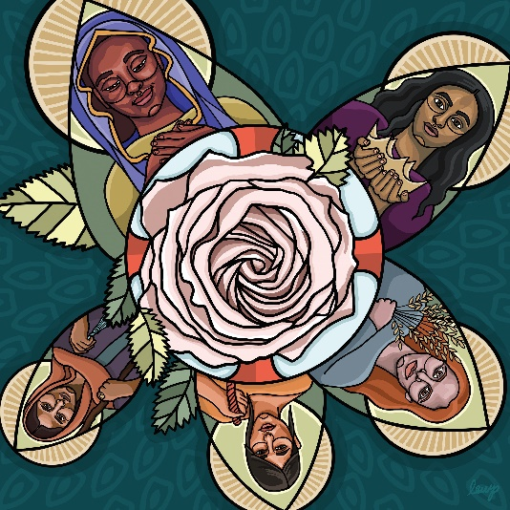
Growing, Loving, & Serving Christ Together!

1280 E. Aurora Rd. Macedonia, Ohio 44056
(330) 467-3169
www.umcofmacedonia.org

Senior Pastor: Rev. Lorrin Radzik
Minister of Congregational Care: Rev. Charles Tobias
Administrative Assistant: Denise Pince
Director of Christian Education: Cathy Miller
Choir & Music Director: Emilio Jarufe
Organist: Amy Sauriol
Treasurer & Media Specialist: Jill Marlow
Thank you for joining us today! To assist you during worship this morning, we offer wireless listening devices, as well as large print bibles and hymnals. Please know that we always love to have the children join us in service, wiggles, noises, and all! Optional nursery care for young children is available in the nursery located next to the Sanctuary. A “Baby and Me” room, which enables you to experience the worship service with your child, is located next to the nursery. All are invited to fill out a prayer card and/or visitor card found in the pew racks. Completed prayer and visitor cards can be passed to the front row to our Minister of Congregational Care.

Opening Ourselves to Worship
* indicates that all are invited to stand.
Gathering Music & Prelude
And There Was a Star David Paxton

Welcome & Greeting

*Call to Worship & Prayer of Confession (Response in bold)
Leader: In God’s house, everyone is welcome— those who seem like they have it all together, and those who feel like their world is falling apart. No matter who we are, there’s room for us here. With that confidence, we turn to God in prayer, speaking the truth of our lives. Let us pray: God of today and God of tomorrow, you say, “Bring your full self. There’s room for you here.”
People: But we say, “Our lives are too messy.”
Leader: You say, “Bring your hopes and your dreams. There’s room for you here.”
People: But we say, “It’s too risky to hope.”
Leader: You say, “Bring your grief and your prayers. There’s room for you here.”
People: But we say, “Some things are easier to forget.”
Leader: God of today and God of tomorrow, we know in our hearts that there’s room for us here.
People: Forgive us for withholding our full selves from you. Forgive us for giving only our Sunday best.
Leader: Help us remember, today and tomorrow,
People: There’s room for every story. Amen.
Leader: Beloved, we who feel scattered are held together. We who have lost our way are forgiven and found. And we who are lonely are brought into the fold and are told, “There’s room for you here.” From generation to generation, this is the good news of the gospel. In Jesus Christ we are held, forgiven, found, and welcomed.
People: Thanks be to God! Amen.

*Hymn Blessed Be the God of Israel No. 209

Hearing God’s Word

Advent Candles & Children’s Message Rev. Lorrin Radzik
Leader: Over a hundred people, from the ages of two to eighty years old, were asked the question, “What gives you hope?” From the voices of different generations, hear their answers…
Rev. Radzik: What gives you hope?
-------------
Rev. Radzik: Today we light the candle of hope to remind ourselves that God is at work in this world.
(The candle of Hope is lit)
People: From generation to generation, God has brought good news of love and compassion, justice and community. Let us rest and abide in that good news. Amen.

First Lesson: Isaiah 2:1-5

Hymn Through the Ages See Insert

Gospel Lesson – Matthew 1:1-17
Leader: For the Word of God in Scripture, for the Word of God among us, for the Word of God within us.
People: Thanks be to God.

Sermon Rev. Lorrin Radzik

*Hymn I Want to Walk as a Child of the Light No. 206

Transforming Our Lives & the World

Sharing of Joys and Concerns Rev. Charlie Tobias
Pastoral Prayer & The Lord’s Prayer
Our Father, who art in heaven, hallowed be thy name. Thy kingdom come, thy will be done on earth as it is in heaven. Give us this day our daily bread. And forgive us our trespasses, as we forgive those who trespass against us. And lead us not into temptation, but deliver us from evil. For thine is the kingdom, and the power and the glory, forever. Amen.

Invitation to Generosity & Offertory
There's a Song in the Air Arr. Dorothy Wells

*Doxology No. 95

*Prayer of Dedication
Holy God, you know our stories and you invite us to be transformed. We come today, offering these gifts and our lives into your hands. Take them, multiply them, and use them in the world, to bring hope and transformation. We pray these things together, trusting in your love. Amen.

*Hymn Hail to the Lord's Anointed No. 203

*Blessing & Sending

Postlude
He Whom Shepherds Once Came Praising Arr. Lani Smith

Today’s Call to Worship, Prayer of Confession, & Advent Candle Lighting are adapted from liturgy by Rev. Sarah (Are) Speed | A Sanctified Art LLC | sanctifiedart.org.
Question for Reflection:
Isaiah’s prophecy paints a powerful illustration of regeneration—of weapons of war becoming plows that break up soil and shears that prune away dead branches. Within your life, church, or community, what needs to be unearthed or dug up? What needs to be pruned away? What steps are required for this work to take place? Where is God regenerating a new path forward?

