Weekly Prayer List

Sunday, November 20
8:30am – Choir Rehearsal
10:00am – Worship & Children’s Sunday School
11:00am – Light Lunch, Hanging of the Greens, & Work Day

Monday, November 21
7:30am – Men’s Breakfast (Luna’s)
8:15am – Bootcamp Exercise Group
10:30am – Women’s Bible Study
6:00pm – Jazzercise

Tuesday, November 22
11:45am – Men’s Lunch (Bob Evans, Macedonia, Oh)
6:00pm – Jazzercise
6:30pm – Women’s Bible Study
7:30pm – Serenity Group

Wednesday, November 23
8:15am – Bootcamp Exercise Group
6:00pm – Jazzercise
8:00pm – Open Arms Support Group

Thursday, November 24
Church Office Closed for Thanksgiving Day

Friday, November 25
Church Office Closed for Thanksgiving Day

Saturday, November 26
8:30am – Jazzercise

Sunday, November 27
8:30am – Choir Rehearsal
10:00am – Worship & Children’s Sunday School

This Week at UMCM

In Our Prayers:
- The family of Rev. Larry Black, who passed away on Saturday, November 12th, at home in Ashland. Larry’s service will be on Saturday, December 3rd, at 1:00 pm at the Christ United Methodist Church in Ashland.
- Lochlan James Smith, (Dustin and Shauna Smith’s son, Kevin and Karen Smith’s new grandson), who was born on Wednesday, November 9th.
- Neil Adams, who is under hospice care.

Giving Thanks to God:
- Praise God for the UMCM Tech Team and all their hard work!
- I want to thank all who have lifted prayers, called, and have sent cards with encouraging words to me while I’m undergoing chemo treatments. They mean so much to me! I am truly blessed,
Marilyn Porter

Altar Flowers
- In memory of Kevin Jackson from his family.

Announcements:
- Check the website and your weekly updates email for other important announcements!
- Following worship, we will have a work day and Hanging of the Greens. Plan to stay for lunch and work. We need your help to prepare for Advent and Christmas!
- Last week’s offering was: $17,426.30
Last week’s attendance was: _30 Online 98 In Person
Question for Reflection:
What does it mean for Christ to be the King of your life? What did you learn about the liturgical year today?
The United Methodist
Church of Macedonia

November 20, 2022
Christ the King
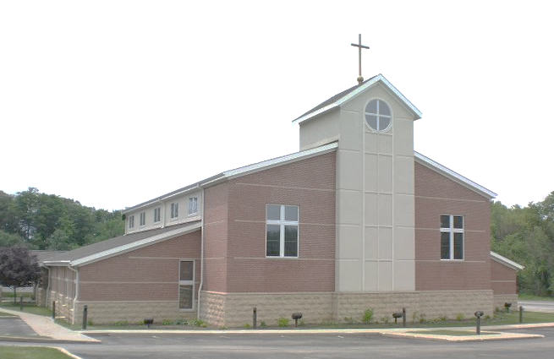

1280 E. Aurora Rd. Macedonia, Ohio 44056
(330) 467-3169
www.umcofmacedonia.org

Senior Pastor: Rev. Lorrin Radzik
Minister of Congregational Care: Rev. Charles Tobias
Administrative Assistant: Denise Pince
Director of Christian Education: Cathy Miller
Choir & Music Director: Emilio Jarufe
Organist: Amy Sauriol
Treasurer & Media Specialist: Jill Marlow
Thank you for joining us today! To assist you during worship this morning, we offer wireless listening devices, as well as large print bibles and hymnals. Please know that we always love to have the children join us in service, wiggles, noises, and all! Optional nursery care for young children is available in the nursery located next to the Sanctuary. A “Baby and Me” room, which enables you to experience the worship service with your child, is located next to the nursery. All are invited to fill out a prayer card and/or visitor card found in the pew racks. Completed prayer and visitor cards can be passed to the front row to our Minister of Congregational Care.

Opening Ourselves to Worship
* indicates that all are invited to stand.
Gathering Music & Prelude
Let All Mortal Flesh Keep Silence Arr. Craig Curry

Welcome & Greeting

*Call to Worship (People’s response in bold)
Leader: Christ Jesus, friend of the poor, the meek and the merciful, has been enthroned above all authority and power in this world and in the world to come.
People: Make a joyful noise to the Lord, all the earth, serve the Lord with gladness, come into his presence with singing.
Leader: God has placed everything under Christ’s wounded feet, appointed the one who wore a crown of thorns as the supreme head of the church, his body.
People: Enter his gates with thanksgiving, come into his courts with praise. Give thanks and praise his loving name!

*Prayer of Confession & Assurance of Forgiveness
Leader: Trusting in grace, let us confess our sins:
Almighty God, you brought forth the world for the love of Christ, yet we have lived in rebellion and turned away from our created purpose. We have acknowledged the Lordship of Christ with our lips, but we have not honored him with our lives. We have served the idols of wealth and privilege; we have sought the protection of violence to oppose violence; we have lived in fear of death and loss; we have not loved our neighbors, nor sought reconciliation with our enemies. Therefore, we pray: Break our rebellious will. Instruct our hearts in the ways of peace. Expose our insincere thoughts. Give us integrity in our quest for truth. Release us from the fear of death. Grant us courage in the face of evil. Free us for joyful service in Christ our Lord. Empower us to live as citizens of your kingdom. For the sake of the world, in the name of Christ our King. Amen.
Leader: Beloved, Christ the King has laid down his life for us. In the name of Jesus Christ you are forgiven.
People: Thanks be to God! Amen.

*Hymn Crown Him With Many Crowns (v 1 & 4) No. 327

Hearing God’s Word

Children’s Message Rev. Lorrin Radzik

Choral Anthem Ecce Ancilla Michael John Trotta

A Festival of Scripture & Song for Christ the King

Introduction
Advent
Scripture Lesson: Isaiah 11:6-9
Hymn Come Thou Long Expected Jesus No. 196
Christmas
Scripture Lesson: Isaiah 9:6-7
Hymn Good Christian Friends Rejoice (v 1 & 2) No. 224
Epiphany & the Season Thereafter
Scripture Lesson: Isaiah 60:1-3
Hymn We Three Kings (v 1 & 5) No. 254
Lent
Scripture Lesson: Luke 23:33-43
Hymn What Wondrous Love is This (v 1 & 2) No. 292
Easter
Scripture Lesson: John 20:11-18
Hymn Christ the Lord is Risen Today (v 1, 3, & 6) No. 302
Pentecost & the Season Thereafter
Scripture Lesson: Acts 2:1-4
Hymn O For a Thousand Tongues to Sing (v 1 & 7) No. 57
Conclusion: Christ the King
Scripture Lesson: Philippians 2:5-11
Hymn All Hail the Power of Jesus’ Name (v. 1 & 6) No. 154

Transforming Our Lives & the World

Sharing of Joys and Concerns Rev. Charles Tobias

Pastoral Prayer & The Lord’s Prayer
Our Father, who art in heaven, hallowed be thy name. Thy kingdom come, thy will be done on earth as it is in heaven. Give us this day our daily bread. And forgive us our trespasses, as we forgive those who trespass against us. And lead us not into temptation, but deliver us from evil. For thine is the kingdom, and the power and the glory, forever. Amen.

Prayer Response Hear Our Prayer George Whelpton

Invitation to Generosity & Offertory
Fling Wide the Door Arr. Joseph Prentiss

*Prayer of Dedication
Almighty God, receive our offering for the sake of Christ our Lord. Make us worthy stewards of your gifts and generous citizens of the kingdom of your Son, Jesus Christ, through whom we pray. Amen.

*Hymn Rejoice the Lord is King (v 1 & 4) No. 715

*Blessing & Sending

Postlude Prepare the Way, O Zion Arr. Richard Blake
Today’s Festival of Scripture and Song was originally written by the Rev. Allison LeBrun and adapted for our use. Today’s Call to Worship was adapted from http://www.bruceprewer.com/DocA/64XKing.htm and the Confession is adapted from Feasting on the Word Worship Companion, Year C, Vol. 2, Reign of Christ.

