Weekly Prayer List
This Week at UMCM

Sunday, November 13
8:30am – Choir Rehearsal
10:00am – Worship & Children’s Sunday School
5:00pm – LIMITLESS Sky Zone Event

Monday, November 14
7:30am – Men’s Breakfast (Luna’s)
8:15am – Bootcamp Exercise Group
10:30am – Women’s Bible Study
6:00pm – Jazzercise
6:30pm – UCB Meeting

Tuesday, November 15
6:00pm – Jazzercise
6:30pm – Women’s Bible Study
7:30pm – Serenity Group

Wednesday, November 16
8:15am – Bootcamp Exercise Group
11:30am – Faithful Friends
6:00pm – Jazzercise
8:00pm – Open Arms Support Group

Thursday, November 17
6:30pm – Kitchen Talk Support Group

Friday, November 18
8:15am – Bootcamp Exercise Group
7:00pm – Come and Get it Support Group

Saturday, November 19
8:30am – Jazzercise
2:00pm – James-Kelly Schreck B-day Party

Sunday, November 20
8:30am – Choir Rehearsal
10:00am – Worship & Children’s Sunday School
11:00am – Light Lunch, Hanging of the Greens, & Work Day

In Our Prayers:
- Caitlin Harris (niece of Greg and Sue Harris, granddaughter of Naomi Harris), who gave birth to a baby girl (6 weeks early), Elena, who is hospitalized at Rainbow Babies and doing well.
- Rev. Mollie Brown, recovering from a cardiac ablation (Mollie and her husband, Doug, are former member of UMCM – Mollie currently serves as the pastor of Westlake UMC).
- Neil Adams, who is in long term memory care at Arbors at Stow.
- Prayers for a co-worker of Joanne Taylor’s, who has been diagnosed with stage four lung cancer.
- Rev. Larry Black, retired pastor, who is at home under hospice care.
- Bob Hohs, whose surgery went well. Thank you for all the prayers and good wishes.
- The family of Russell Wolfe, who passed away on Thursday, November 10th. No arrangements have been made.

Giving Thanks to God:
A special thank you to the congregation and choir for the very generous love offering and gift cards that I received this week. It was a privilege to serve as your organist and be part of such a caring and loving church family.
Sincerely,
Joanne Taylor

Announcements:
- Check the website and your weekly updates email for other important announcements!
- Next week following worship we will have a work day and Hanging of the Greens. Plan to stay for lunch and work. We need your help to prepare for Advent and Christmas!
- Last week’s offering was: $11,454.99
Last week’s attendance was: _27_ Online 105 In Person

The United Methodist
Church of Macedonia

November 13, 2022
23st Sunday after Pentecost
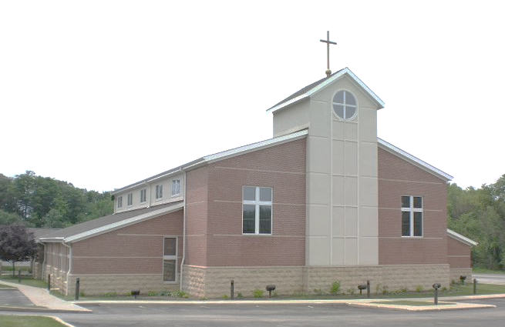

1280 E. Aurora Rd. Macedonia, Ohio 44056
(330) 467-3169
www.umcofmacedonia.org

Senior Pastor: Rev. Lorrin Radzik
Minister of Congregational Care: Rev. Charles Tobias
Administrative Assistant: Denise Pince
Director of Christian Education: Cathy Miller
Choir & Music Director: Emilio Jarufe
Organist: Amy Sauriol
Treasurer & Media Specialist: Jill Marlow
Thank you for joining us today! To assist you during worship this morning, we offer wireless listening devices, as well as large print bibles and hymnals. Please know that we always love to have the children join us in service, wiggles, noises, and all! Optional nursery care for young children is available in the nursery located next to the Sanctuary. A “Baby and Me” room, which enables you to experience the worship service with your child, is located next to the nursery. All are invited to fill out a prayer card and/or visitor card found in the pew racks. Completed prayer and visitor cards can be passed to the front row to our Minister of Congregational Care.

Opening Ourselves to Worship
* indicates that all are invited to stand.
Gathering Music & Prelude
I Need Thee Every Hour Arr. Robert W. Thygerson

Welcome & Greeting

*Call to Worship (People’s response in bold)
Leader: We are called to be people of faith in the midst of the world,
People: And so we mix our worship and our work, our faith and our life.
Leader: We gather here as people who live in the world and yet,
People: We gather as people who have been called to see the world from a different viewpoint.
Leader: God has called us together, God has called us to be part of a community.
People: God challenges us to consider questions of priority as we engage with the world.
Leader: In this time together,
People: May God open our hearts, minds and eyes,
Leader: Allowing us to see deeper, helping us to live in the world while still offering a challenge to the ways of the world.
People: We pray in Jesus' name. Amen.

*Unison Prayer
Creator God, whose Son was a carpenter, you have put within us the desire to be creative through the thoughts of our brains and the work of our hands. Enable us so to order our society that none may be denied the right
to work for a fair wage, so that full employment and just relationships may characterise the industries of our world. In Jesus' name. Amen.

*Hymn Open My Eyes That I May See No. 454

Hearing God’s Word

Children’s Message Rev. Andrew Scott

Epistle Lesson: 2 Thessalonians 3:6-13

Choral Anthem Draw Us in the Spirit’s Tether Friedell

Gospel Lesson – Luke 21:5-19
Leader: For the Word of God in Scripture, for the Word of God among us, for the Word of God within us
People: Thanks be to God.

Sermon “Living Love, Showing Heart” Rev. Andrew Scott

*Hymn Two Fishermen No. 2101

Transforming Our Lives & the World

Sharing of Joys and Concerns Rev. Charles Tobias

Pastoral Prayer & The Lord’s Prayer
Our Father, who art in heaven, hallowed be thy name. Thy kingdom come, thy will be done on earth as it is in heaven. Give us this day our daily bread. And forgive us our trespasses, as we forgive those who trespass against us. And lead us not into temptation, but deliver us from evil. For thine is the kingdom, and the power and the glory, forever. Amen.

Prayer Response Amen David H. Williams

Invitation to Generosity

Offertory Quiet Devotion R. Kevin Boesiger

*Doxology No. 95

*Prayer of Dedication
Loving God, before we give to you, you have given to us. All we offer we have received from you. We thank you for your goodness, and we praise you for your bountiful works, though Christ by the power of the Holy Spirit. Amen.

*Hymn They’ll Know We are Christians by Our Love No. 2223

*Blessing & Sending

Postlude A Joyous Benediction David Paxton
Question for Reflection:
Paul writes: “Brothers and sisters, do not be weary in doing what is right” (2 Thess. 3:13). Even Paul realizes that it can become tedious to work for justice. What are ways that we might stay energized in a seemingly impossible task?

Today’s Call to Worship was by Rev Gord on his blog, Worship Offerings. http://worshipofferings.blogspot.ca/
Today’s Unison Prayer was by Michael Saward. Posted on The Jubilate Group website. http://www.jubilate.co.uk/liturgy/
The Prayer of Dedication was from adapted from “Feasting on the Word Worship Companion, Year C, Volume 2,” Proper 28

